Information about the Moomba Foundation and their new mission

The Moomba Foundation had been incorporated for the wellbeing of wild animals living in captivity. We aim to make a distinction between animal parks that are involved with canned hunting/cub petting and the parks that do good. The good and ethical parks are entitled to and will receive a Moomba certificate. Please find more information on our website www.moombafoundation.com

Currently we are working on a new mission:

The Moomba Foundation is excited to announce that we have been requested to assist with a most urgent and necessary rescue of 7 tigers, 2 ligers, and 4 Lions from a forced closed down zoo in Argentina. For this important operation, we committed ourselves in a joint operation with Ubuntu Spirit of Africa, to raise the necessary funds to enable us to relocate these big cats to South Africa. With Ubuntu, the Moomba Foundation have worked together in the past on another big cat rescue mission.

Ubuntu: Spirit of Africa Wildlife Rescue and Rehabilitation Sanctuary

was founded in 2016 with the purpose of rescuing orphaned, injured, sick or traumatized wildlife species, specifically white and black rhino, and to rehabilitate and release these animals back into wild meta populations. To rescue captive wildlife species, specifically predators, from unethical, inhumane and unacceptable captive conditions and provide these rescued animals a safe, secure, ethical and professionally managed sanctuary to the highest international standards providing in their physical, emotional and psychological needs.

Why this Argentinean tiger& lion rescue?

the municipality from la Rioja, Argentina has expropriated the city zoo after it became clear that the animals had to live under miserable conditions. For 20 years, the former owner, Mr. Rodriguez could run an illegal breeding farm under the guise of a zoo and sold big cat cubs to circus owners and private individuals on the one hand and on the other hand accepted subsidies.

Although the Mayor and his colleagues bravely stepped into care for the abandoned animals in 2016, they are no animal keepers by profession and could only provide basic care while to many animals must live in too small enclosures. Therefore, a private initiative was raised to find a new home for these cats. Unfortunately, very few wildlife sanctuaries are interested in such tigers and lions thus finding new homes for these cats is almost impossible.
The possible salvation
In cooperation with the owners of the Ukuthanda Lodge in South Africa, Ubuntu agreed to create a new forever home for these unfortunate animals on 500 hectares of prime indigenous land in the beautiful North West Province of South Africa.
The Argentinean big cats are now ready to be relocated to large natural enclosures designed to give them adequate space to exercise and stimulate their natural senses. There they will be able to swim in large natural pools, experience the smells and sounds of nature; live in a natural environment with natural bush, trees etc.
To achieve this, we are in great need of financial contributions, donations, sponsorships and a volunteer program to cover flight costs, camp construction, specialized veterinary costs, initial specialized feeding costs, etc at a total costs of US$ 559.000

Here is an impression of how the animals lived before the Municipality took over:

No shade for the lion…

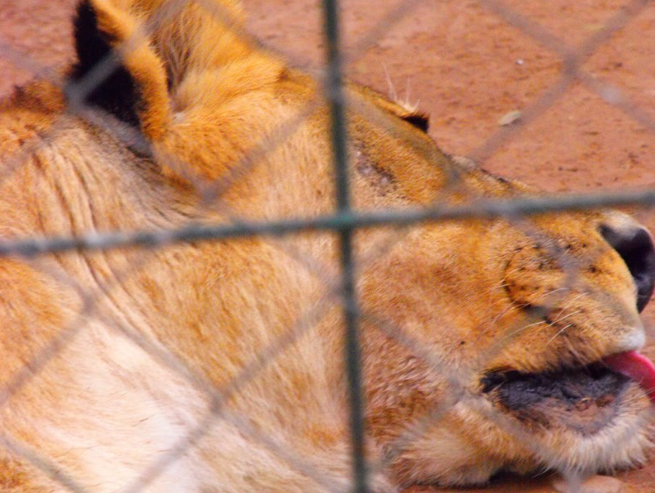
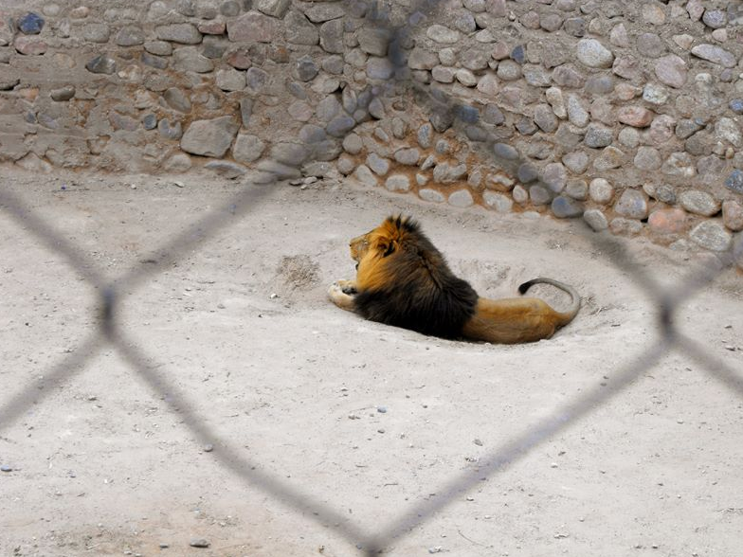
Enclusures with 1.5mtrs width
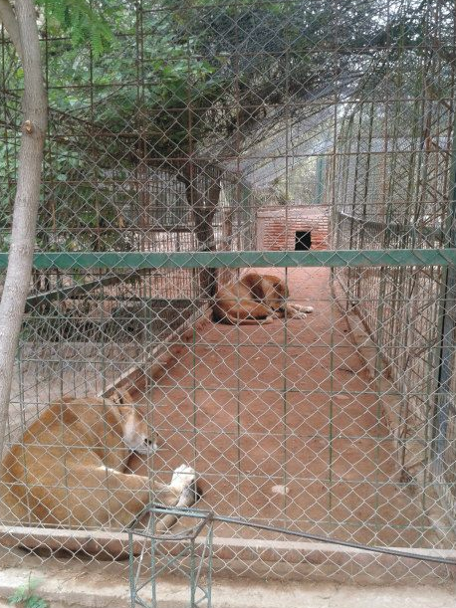

Only concrete except for a few centimeters:
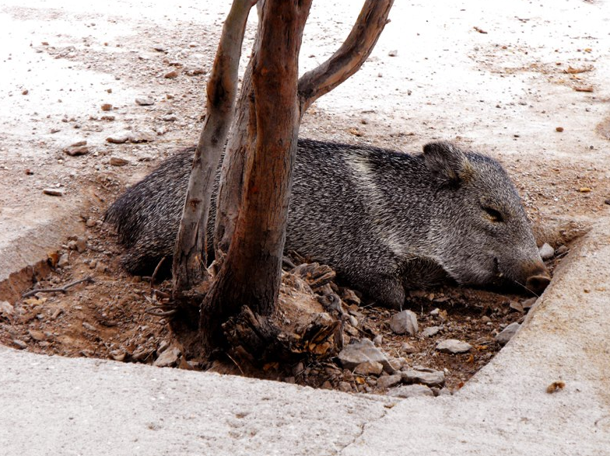

Untreated wounds:

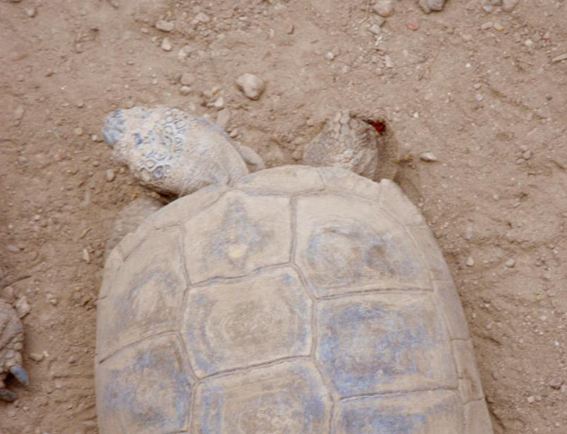

Hardly any security: no padlock (also look at the haircondition of the tiger)

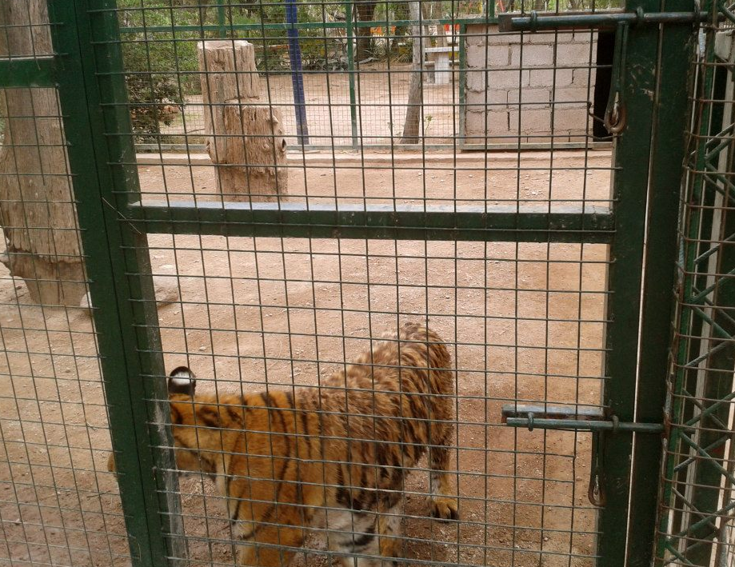

Complete abandonment (look at the water):
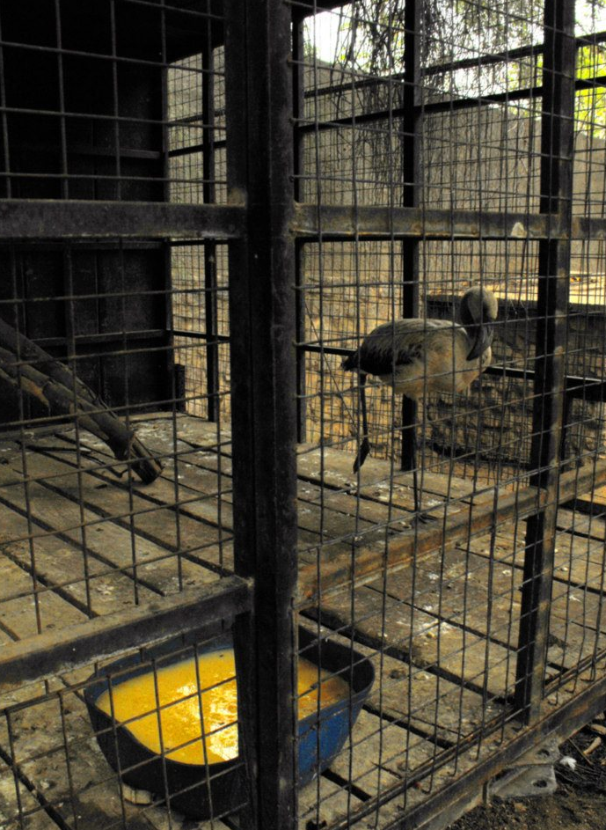

If you like to donate to this foundation
You can donate to SPURT account: 5630459.

